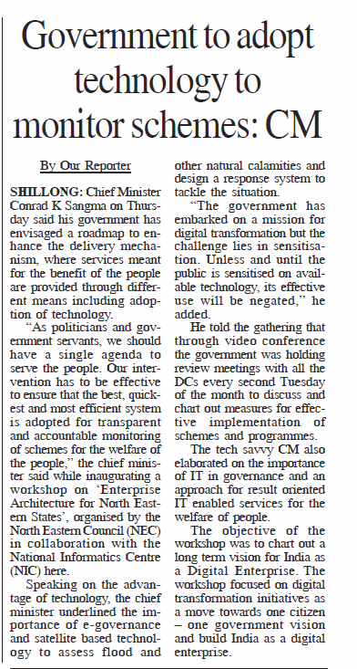

The Shillong Times: http://epaper.theshillongtimes.com/epaperimages/1082018/1082018-md-hr-10.pdf

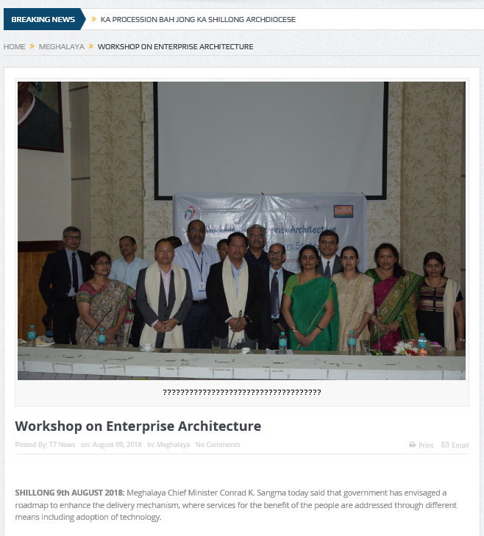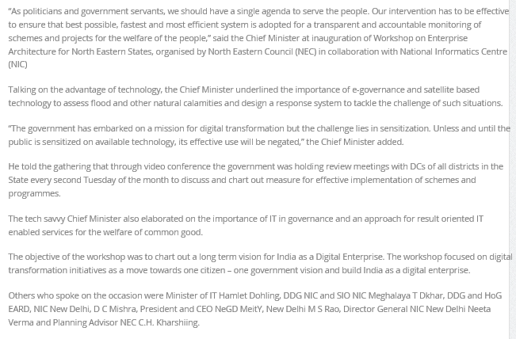
http://t7news.in/workshop-on-enterprise-architecture/

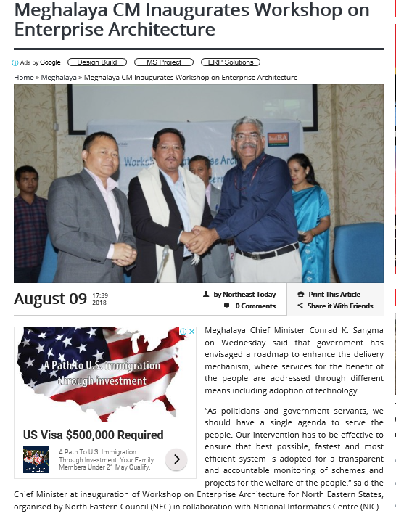
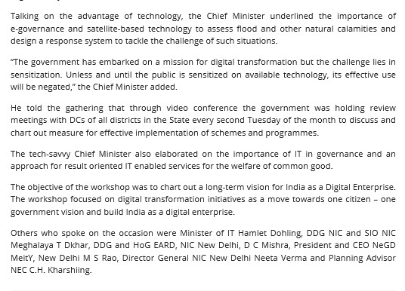
https://www.northeasttoday.in/meghalaya-cm-inaugurates-workshop-on-enterprise-architecture/

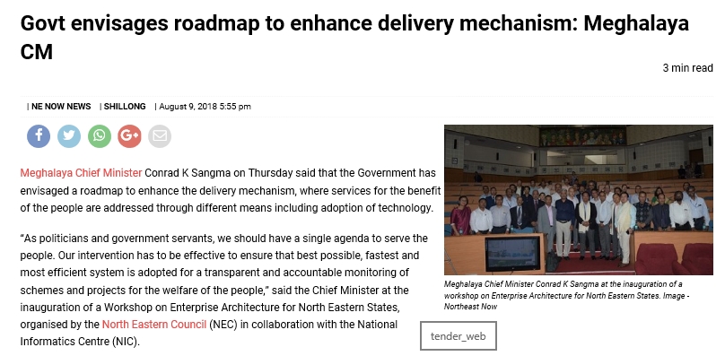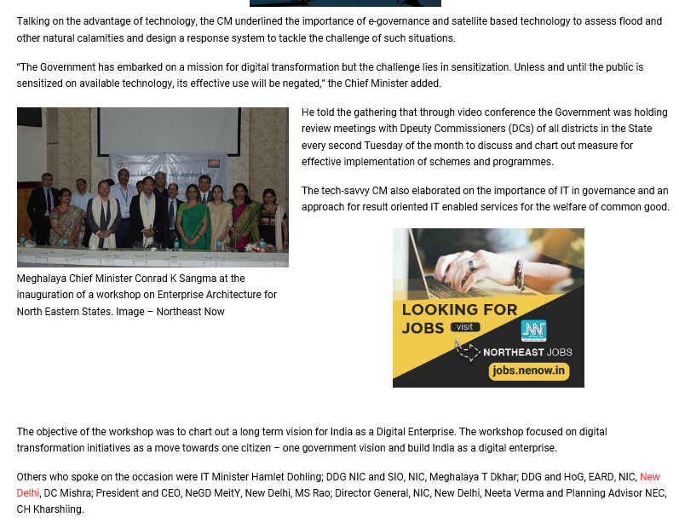
https://nenow.in/north-east-news/govt-envisages-roadmap-to-enhance-delivery-mechanism-meghalaya-cm.html

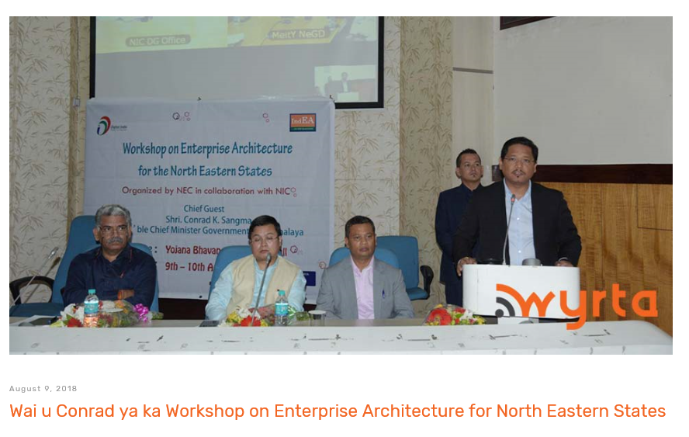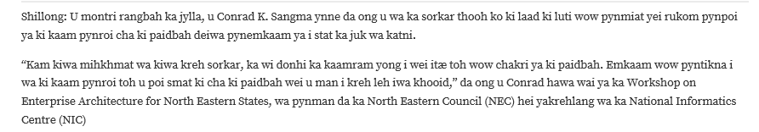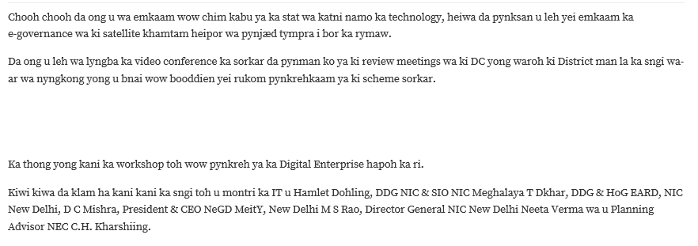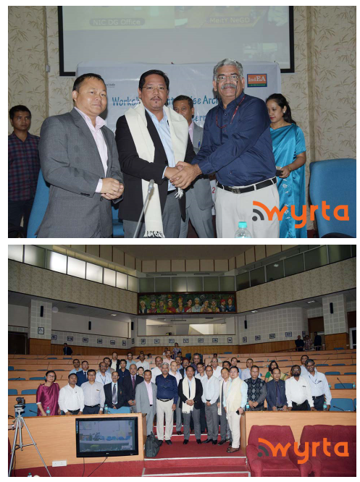http://wyrta.com/wai-u-conrad-ya-ka-workshop-on-enterprise-architecture-for-north-eastern-states/

